# **Name: Abdurrahman Qureshi**

# **Roll No: 210451**

Practical No: 6

**QUESTION |**

**1.)Increase salary by 20% and display the names of the employees.**

**OUPUT:**

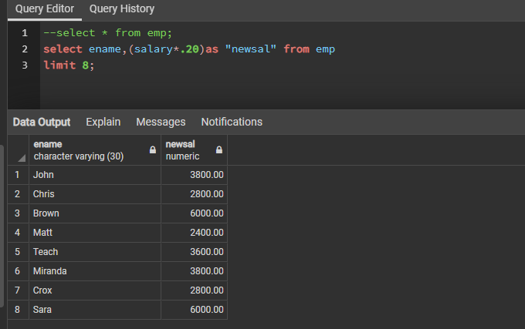

**2.)Select ename,eno from emp where salary >= 15000 and >= 10000;**

**OUTPUT:**

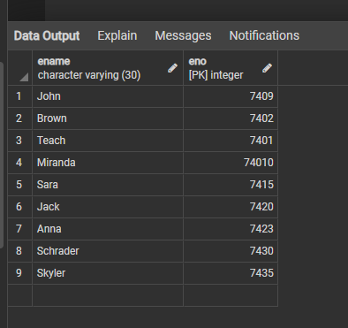

**3.) Select details of employees having salary more than Skyler.**

**OUTPUT:**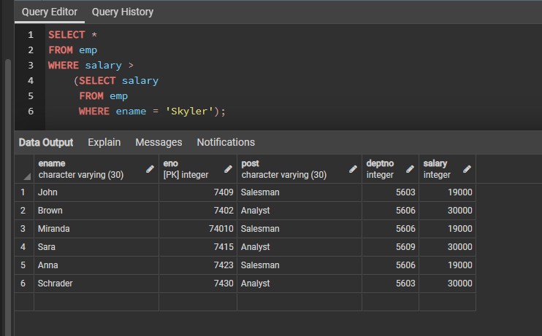

**4.)Select * from emp where deptno<>5606**

**OUPUT:**

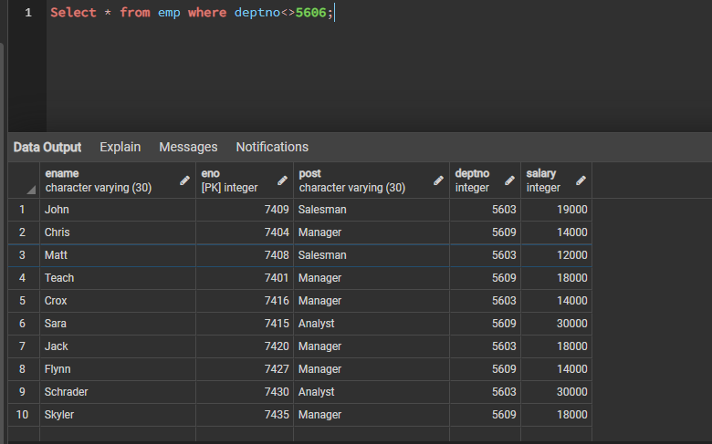

**Question ||**

**1.)Select * from emp union from dept;**

**OUTPUT:**

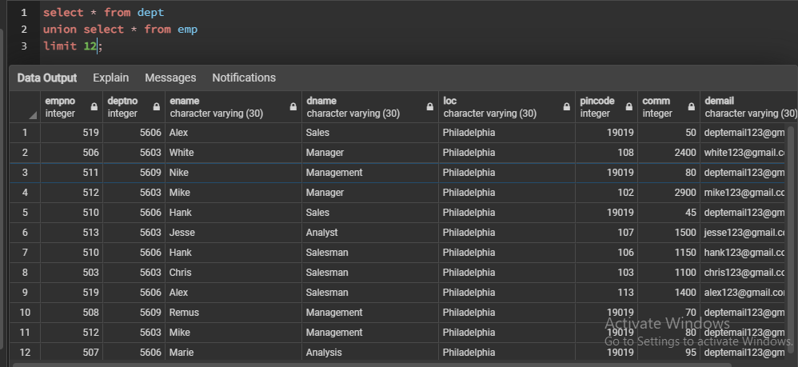

**2.)Select ename from emp intersect select ename from dept**

**OUPUT:**

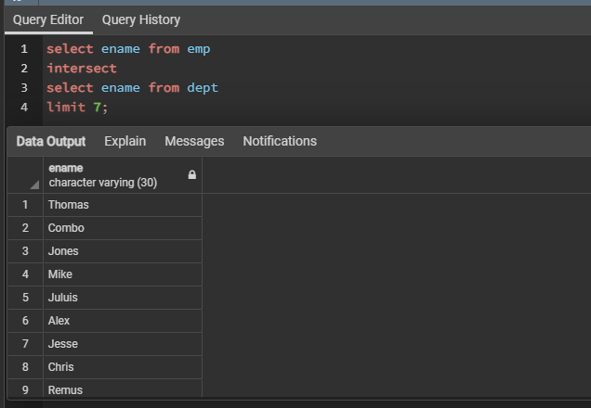

**3.) Select ename from emp except/minus select ename from dept**

**OUTPUT:**

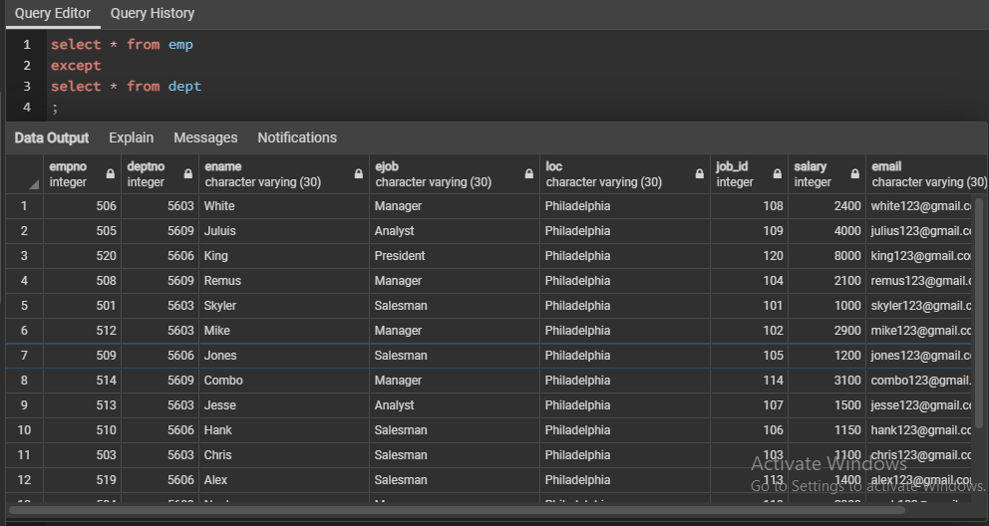

**4.)Select * from emp where salary between 1500 and 4000**

**OUTPUT:**

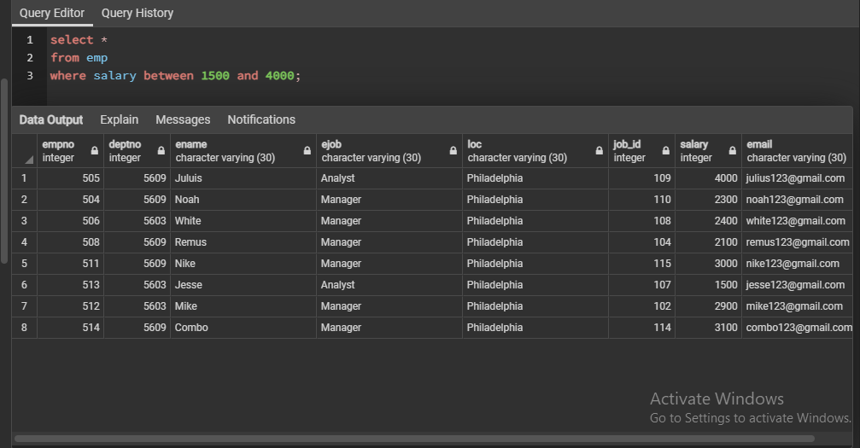

**5.)Select * from emp where ename in (‘White’)**

**OUTPUT:**

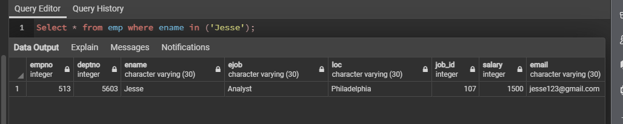

**Question |||**

**1.)Display name of employees whose deptno is not 5606**

**OUTPUT:**

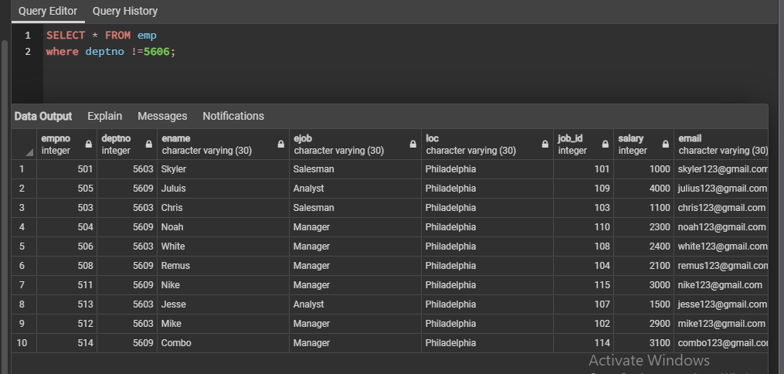

**2.)Display names where ename is 6 characters long**

**OUTPUT:**

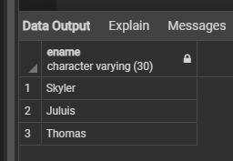

**3.)List employees where deptno isn’t 5603 and 5609**

**OUTPUT:**

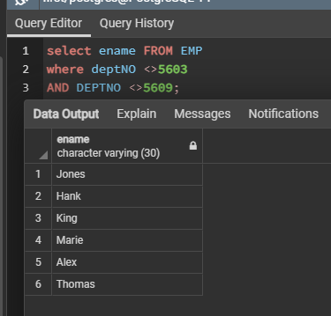

**4.)List employees whose salary is not in range of 2500 and 4000**

**OUTPUT:**

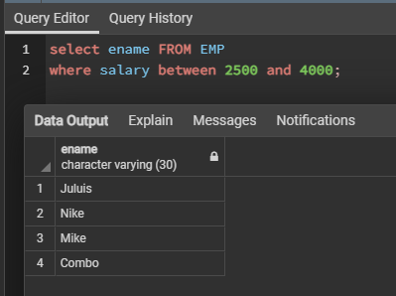

**5.)List common enames from emp and dept**

**OUTPUT:**

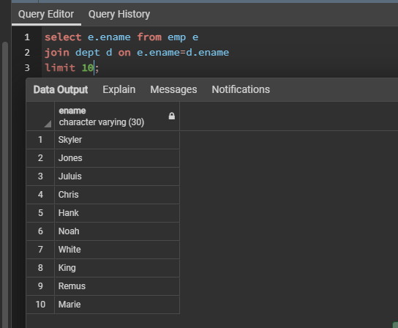

**6.)List employees whose salary is more than 3500 after salary is incremented by 15%.**

**OUTPUT:**

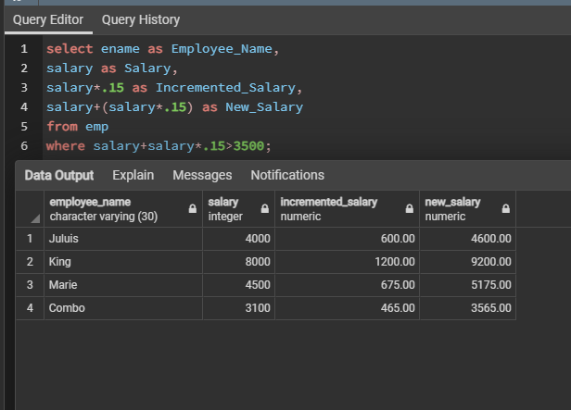

**QUESTION |V**

**1.)Select names where sal>3000 and dname=sales**

**OUTPUT:**

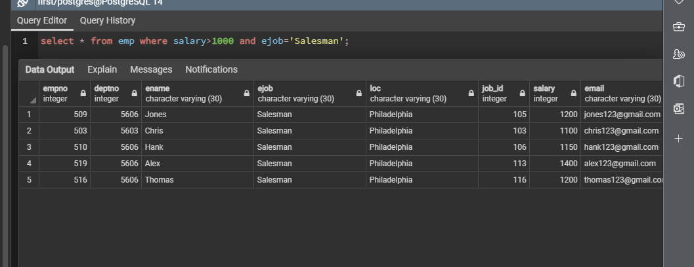

**2.)Select * from emp where ejob isn’t sales.**

**OUTPUT:**

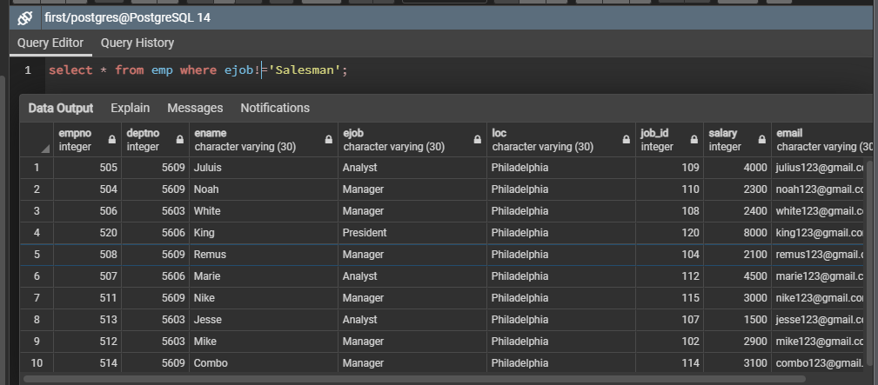

**3.)Select * from emp where ename starts with s.**

**OUTPUT:**

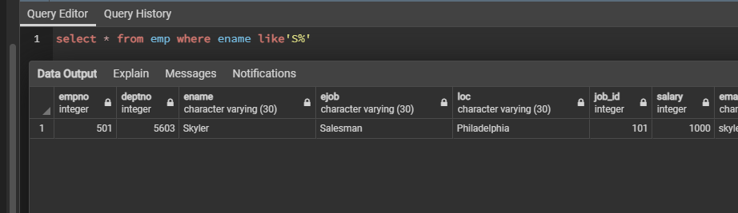

**4.) Select * from emp where ename has ‘s’.**

**OUTPUT:**

